Exercise 11
- Count the number of employees who have been with Bignet for four or more years.
SELECT count(id) from employee_data where yos >= 4;
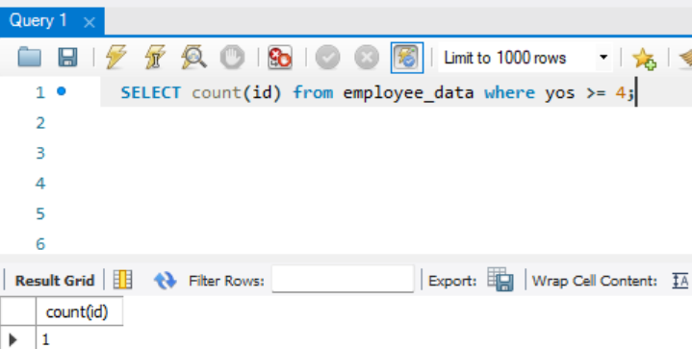
- Count employees based on their ages.
SELECT count(id) as count, age from employee_data GROUP BY age;
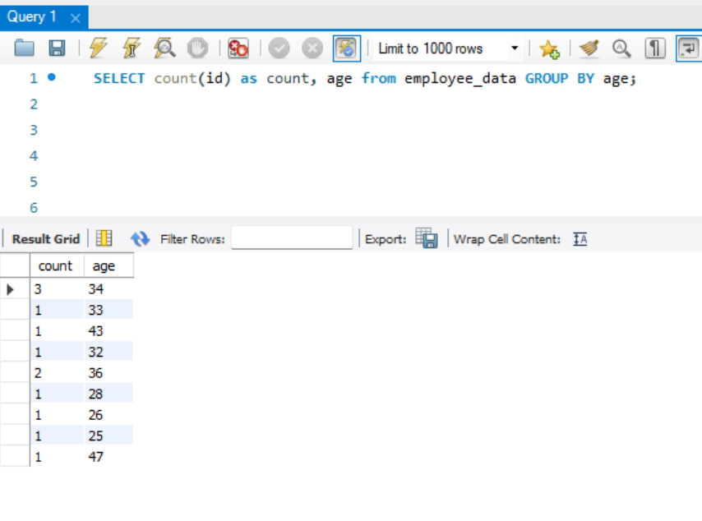
- Modify the above so that the ages are listed in a descending order.
SELECT count(id) as count, age from employee_data GROUP BY age ORDER BY count DESC;
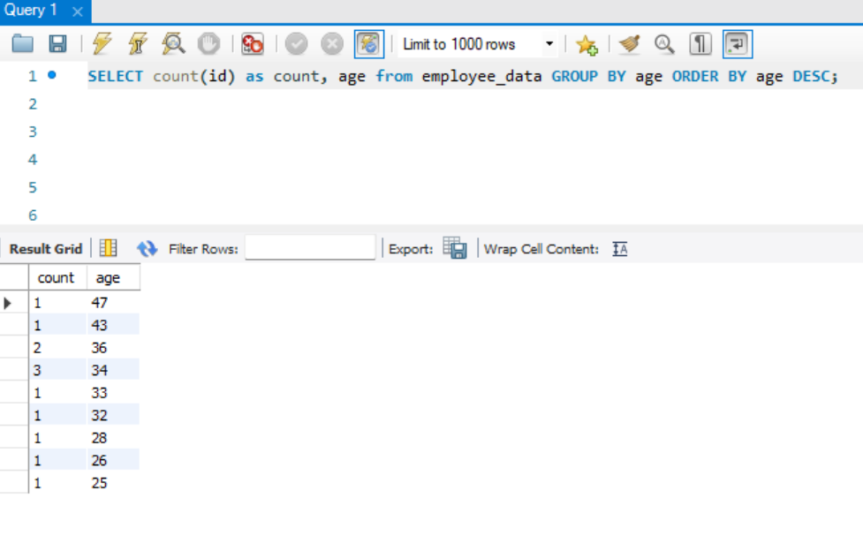
- Find the average age of employees in different departments (titles).
SELECT AVG(age) as avg_age, title from employee_data GROUP BY title;
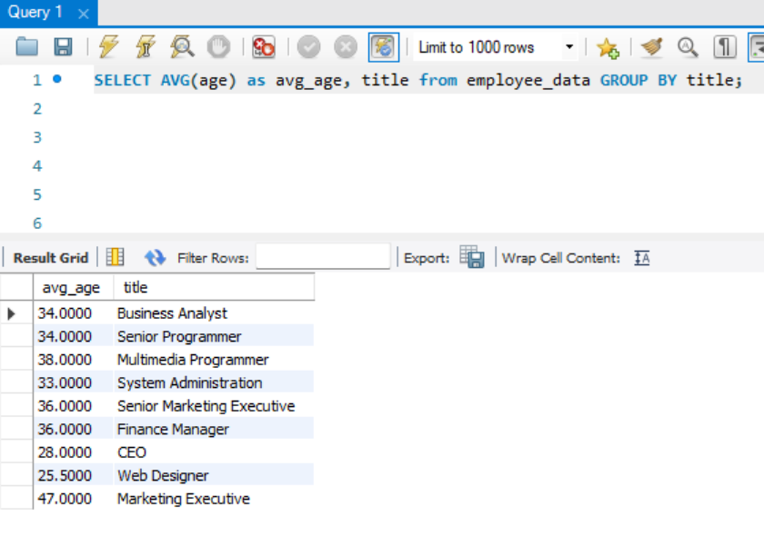
- Change the above statement so that the data is displayed in a descending order of average ages.
SELECT AVG(age) as avg_age, title from employee_data GROUP BY title ORDER BY avg_age DESC;
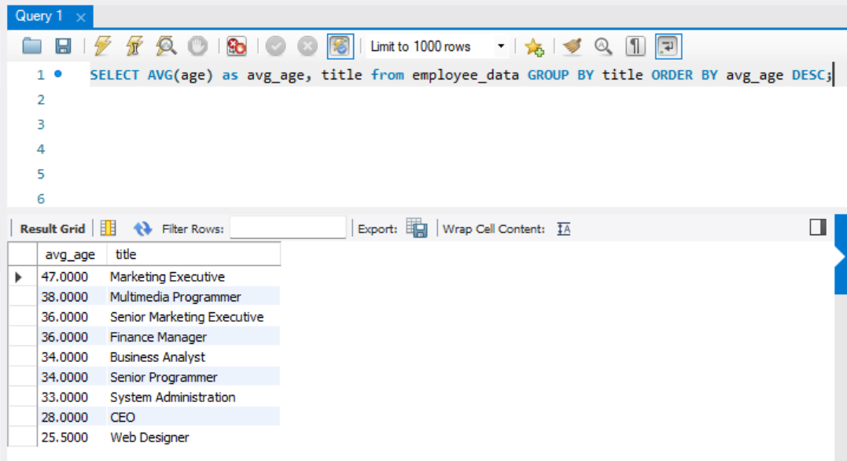

- Find and list the percentage perk 9perk/salary x 100 for each employee with the 5 perks sorted in a descending order.
SELECT CONCAT((perks/(salary*100))*100, "%") as perks_percentage from employee_data ORDER BY perks_percentage DESC;
